## More functions

If you are familiar with PLC programming, you’ll know that it is mostly about function blocks.

A generalized function block consists of input variables, output variables, through variables, internal variables, and an internal behavior description of the function block. Input variables can only be written from outside of an FB. From inside they can only be read. Output variables can be read and written from inside of an FB and only be read from outside. Through variables are special shared variables. If through variables of different FB instances are connected, they do all access the variable connected to the first input of the chain. Through variables are defined in [IEC 61131]. They are often called In-Out-variables. If their datatype matches, output variables can be connected to input variables by a connector. This is similar to a connection of ports with matching protocols.

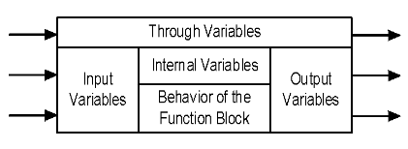

Figure 8‑7: General function block model

In Table 8‑1 you can see which function blocks are declared in FT NavVision® these are the most commonly used.

If, for example, you want to make a program with a set and reset and different variables, it can go like the following.

Click on the left side of the 0 and choose “Function AND”. A function block with the AND denominator will appear (see Figure 8‑8). Now you can define the fields or variables that need to be true (all) to make the AND box work. In the example we use two denominators. So we need to assign two fields to the left side of the box.

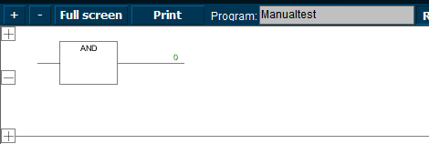

Figure 8‑8: the AND box

First click at the left side of the line and choose “Assign field”. We choose an expansion tank overload (see Figure 8‑9). Now we want the pump (that we implement later) to start only as both SB and PS expansion are at overload. We need to add the other tank in front of the ADD-box. Click at the bottom left and choose “Assign field” and add the other tank (see Figure 8‑10).

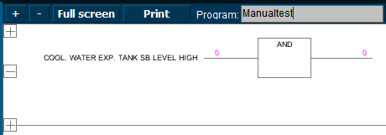

Figure 8‑9: Example 1

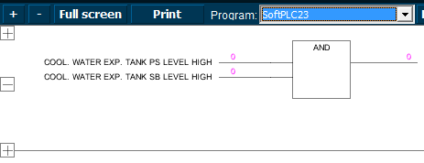

Figure 8‑10: Example 2

Now we want the pump we are going to add to be started as both fields are true (1). But we cannot only set the pump, we also need to reset it. So at the right side after the “0” we will put a set/reset box. Click and choose “Function SR” you’ll get a set/reset box (see Figure 8‑11).

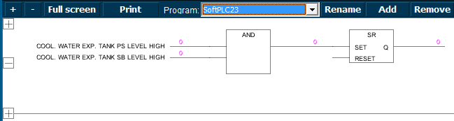

Figure 8‑11: Example 3

Now we have the SET-side ready. If both tanks get a high alarm (1) it will get high on the set/reset box which will set the other side of the box. Here we can put the field for the desired pump so that pump will start as the box is set. Click all the way right and choose “Assign field” and choose the appropriate field. It will look like the following figure:

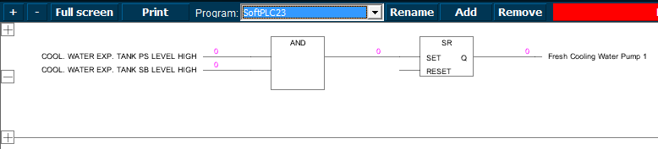

Figure 8‑12: Example 4

So, the SET is made. The pump will run once the conditions are met. However we do want to reset the pump as well. In the Set/Reset-box you see a reset entrance. Click here and choose “Function AND” or “Function OR” whichever you want to use. We will use the AND-function for this example. You will get a new “AND” box which we will connect to the same fields as we did in the first box. Except this time we will negate them. This means that the conditions are met if the field is NOT high (1) or in this case they must be low (0) to meet the conditions. You can negate these fields by clicking your mouse at the line near the box. A circle will appear (see Figure 8‑13).

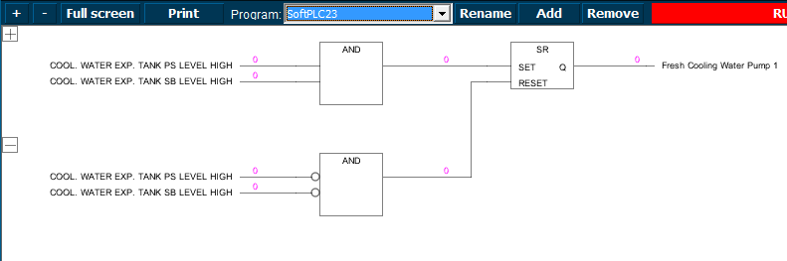

Figure 8‑13: Example 5

Conclusion: this program makes the “Fresh cooling water pump” run as both tank level alarms gets high. This will remain so until both tank level alarms are out of alarm after which the switch will reset the pump.

## Extended

Of course you can extend this program as far as you wish, but that Is beyond the scope of this manual. This manual is merely to show you how to work with the SoftPLC. Just as a reference we will show you some more examples to get familiarized with the program.

### Example 1

The example we used in paragraph 8.6 is a little bit straight forward. It is just on and of switching of a pump depending on the state of a couple of level switches. Now we can change that to make it more accurate by, for example reset the pump when either of the alarms goes out of alarm (see Figure 8‑14). This is easily changed by clicking on the box. A drop-down menu appears where you can choose all the functions (see Figure 8‑15).

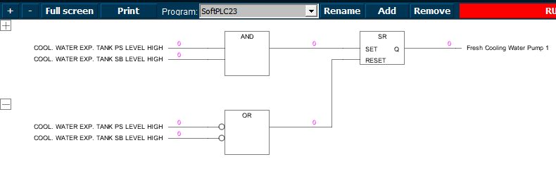

Figure 8‑14: Extended example 1

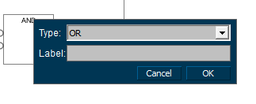

Figure 8‑15: Drop down box

You can even give the function blocks a label. Just to keep it synoptic in bigger programs.

### Example 2

In example 1 we changed AND to OR. So now the pump will be rest if one of the level alarms will get low (0). You can imagine that you want the pump to run a little longer, just to empty a little bit more out of the tanks. This can be done by adding a timer between the OR-box and the reset.

Click at the height of the “0” at the right side of the OR-box. Choose “Function TON” A timer box will appear (see Figure 8‑16). Now you can set a time (in milliseconds) that the OR-function will hold until it will give the function to the reset. If you like the function to wait for 10 seconds then you click the line before PT and choose “Assign value”. A box will appear. Type 10000 (for milliseconds which is 10 seconds) and choose OK (see Figure 8‑17). Now the timer will wait 10 seconds before it will trigger the reset.

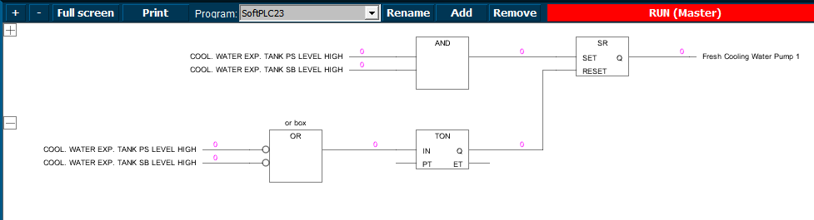

Figure 8‑16: Add TON

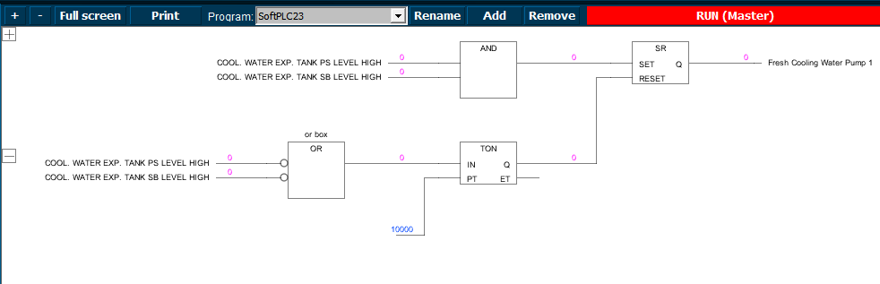

Figure 8‑17: Add milliseconds

*: to remove a particular box, value or field, just hover your mouse over it and press “Delete”.*